**Testing For Speeding Ticket Program**

**Testing Table for formatting of Fines and Speed Ranges (per line / entry basis):**

|  |  |  |
| --- | --- | --- |
| **Input:** | **Expected Output:** | **Actual Output:** |
| 1-10-30 | Accepts | *Accepts* |
| 41-45-510 | Accepts | *Accepts* |
| 11min-15max-80fine | Prints Warning that data format is incorrect and asks whether to continue to abort. Also warns If were to continue, errors may occur. | ** |
| 16,20,120 | Prints Warning that data format is incorrect and asks whether to continue to abort. Also warns If were to continue, errors may occur. | ** |
| 31-35-$300 | Prints Warning that data format is incorrect and asks whether to continue to abort. Also warns If were to continue, errors may occur. | ** |
| one-ten-thirty | Prints Warning that data format is incorrect and asks whether to continue to abort. Also warns If were to continue, errors may occur. | ** |
|  |  | **Those that have a warning also has this displayed: |

**Testing Table for Formating of Speeding Data (per line / entry basis):**

|  |  |  |
| --- | --- | --- |
| **Input:** | **Expected Output (speed in KM / HR):** | **Actual Output:** |
|  |  |  |
| AKL40,11:04:00  AKL40,11:04:00 | Prints Warning that the entry and exit times are the same |  |
| AKL50,11:04:00  AKL50,11:06:07 | Prints AKL50 as car plate travelling at a speed of 76 and no fine |  |
| DB356,11:04:00  DB356,11:31:12 | Prints Warning that car hasn’t left tunnel within 4 minutes and also prints speed |  |
| D139,11:04:00  D139,11:05:58 | Prints D139 as car plate traveling at a speed of 82 with a fine of $30 |  |
| AKL10,11:08:10  AKL10,11:06:00 | Prints warning that entryTime > exitTime |  |
| FN806,11:04:07  FN806,11:04:34 | Prints __ as car plate with a speed of 358 with a fine of $630 |  |
| AKL60,11:04:00 | Prints warning that the vehicle has been reported to not have exited the tunnel or that data is incorrect! |  |
| AKL70,11-04-00  AKL70,11:06:07 | Prints Warning that data format is incorrect and asks whether to continue to abort. Also warns If were to continue, errors may occur. |  |
| AKL80-11:05:50  AKL80-11:08:07 | Prints Warning that data format is incorrect and asks whether to continue to abort. Also warns If were to continue, errors may occur. |  |
| AKL90 11:01:10  AKL90 11:03:37 | Prints Warning that data format is incorrect and asks whether to continue to abort. Also warns If were to continue, errors may occur. |  |
| AKL10011:01:10  AKL10011:03:37 | Prints Warning that data format is incorrect and asks whether to continue to abort. Also warns If were to continue, errors may occur. |  |
| AKL110,11:01:100  AKL110,011:03:37 | Prints Warning that data format is incorrect and asks whether to continue to abort. Also warns If were to continue, errors may occur. |  |
| AKL120,11hr:02min:10sec  AKL120,11hr:05min:37sec | Prints Warning that data format is incorrect and asks whether to continue to abort. Also warns If were to continue, errors may occur. |  |

**Testing of each fine ranges:**

|  |  |  |  |
| --- | --- | --- | --- |
| **Range:** | **Input** | **Expected output** | **Actual Output** |
| Not speeding | AKL50,11:04:00  AKL50,11:06:00 | 80 KM/HR  *NO FINE* |  |
|  |  |  |  |
| 1 - 10 km/hr | BAK136,11:04:00  BAK136,11:05:55 | 84 KM/HR $30 |  |
| 11 - 15 km/hr | BAL560,11:04:00  BAL560,11:05:45 | 92 KM/HR $80 |  |
| 16 - 20 km/hr | BST1,11:04:00  BST1,11:05:40 | 96 KM/HR $120 |  |
| 21 - 25 km/hr | CKZ52,11:04:00  CKZ52,11:05:35 | 101 KM/HR $170 |  |
| 26 - 30 km/hr | D139,11:04:00  D139,11:05:30 | 107 KM/HR $230 |  |
| 31 - 35 km/hr | DB356,11:04:00  DB356,11:05:25 | 113 KM/HR $300 |  |
| 36 - 40 km/hr | DS323,11:04:00  DS323,11:05:23 | 116 KM/HR $400 |  |
| 41 - 45 km/hr | DCZ584,11:04:00  DCZ584,11:05:20 | 121 KM/HR $510 |  |
| 46 - 50 km/hr | DDA970,11:04:00  DDA970,11:05:15 | 129 KM/HR $630 |  |
| > 50 km/hr | SP33D,11:04:00  SP33D,11:04:50 | 193 KM/HR $630  *Excessive speed* |  |

**Testing For Data File:**

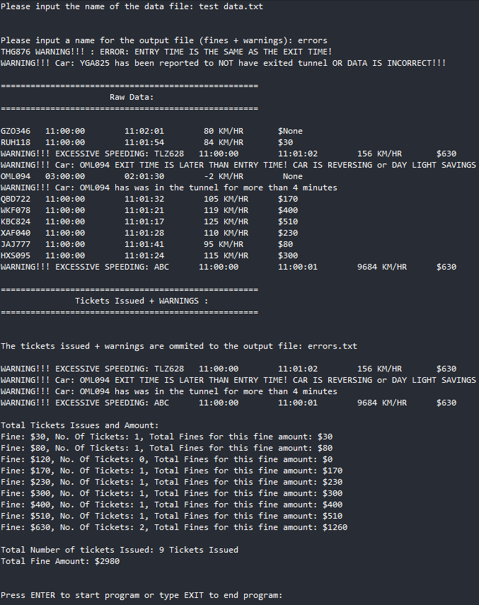

**From output text file:**

